Install docker on EC2 and explore the docker commands (docker images, containers)

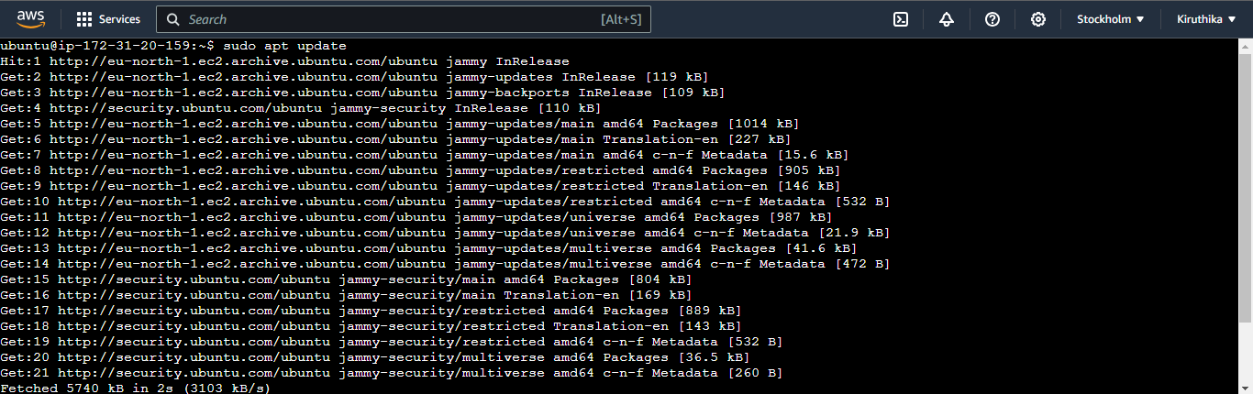

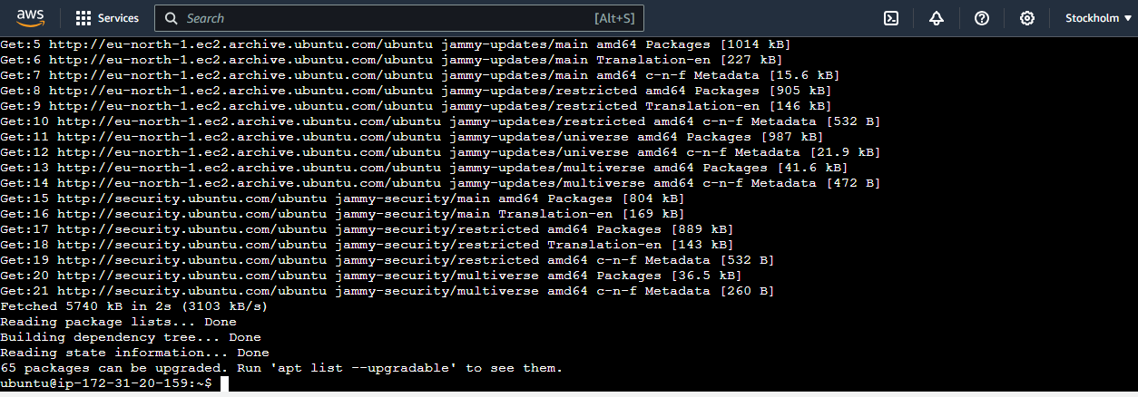

Sudo apt install docker.io command

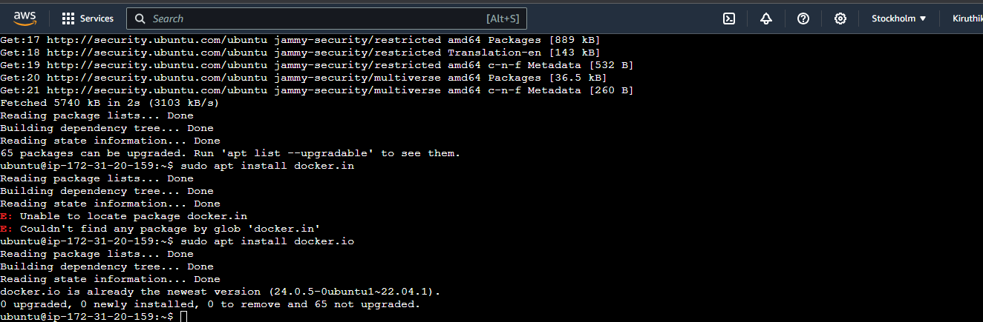

Docker images using hello world

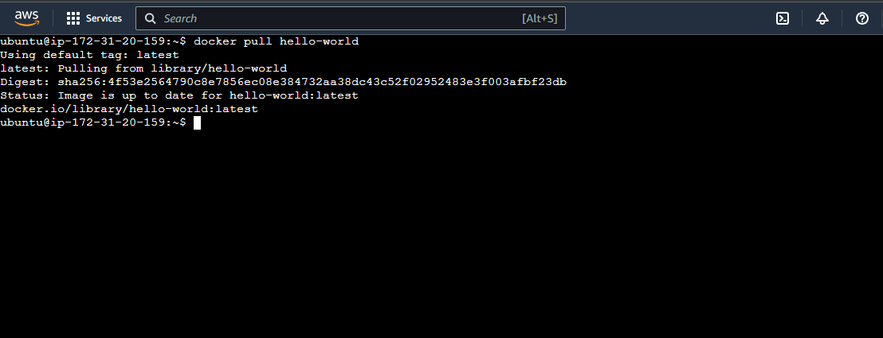

To containerize an image we use docker run command

